21.82: First, the mass of the drop:
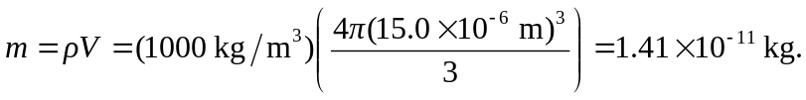
Next, the time of flight:
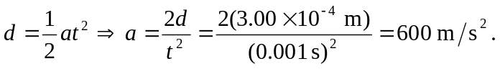
So:

